**3. PHASE DIAGRAM**

**PHASE:** It’s a state of system, all phases of a system are chemically homogeneous but physically distinct & mechanically separable.

**PHASE DIAGRAM:**

It gives information about different phases of a system with respect to temperature and chemical composition.

**DEGREE OF FREEDOM(F):** It’s the number of independent variables required to define the system.

|  |  |
| --- | --- |
| **GIBBS PHASE RULE:** applicable to Water, Carbon, Water Bottle, … $$F+P=C+2$$ **MODIFIED GIBBS PHASE RULE:** Alloy, … $$F+P=C+1$$ | $F$ = Degree of freedom, $P$ = No. of Phases, $C$ = No. of components (E.g. Pressure, Temperature), |

**HUME RUTHERY RULES:**

|  |  |  |
| --- | --- | --- |
|  | **Substitutional Solid Solution** | **Interstitial Solid Solution** |
|  | This is formed by adding solute atoms in place of solvent materials atoms. E.g. Fe-Cr Alloy. | This is formed by adding solute atoms at interstitial Position of solvent materials atoms. E.g. Fe-C (Steel). |
| **Size Factor** | $R_{Solvent}-R_{Solute}<15\%$ | $$R_{Solvent}≫≫≫R_{Solute}$$ |
| **Crystal Structure** | Same |  |
| **Electro negativity** | It’s chemical affinity to make a bond. Hence, Electronegativity must be low. |  |
| **Valence Electron** | Difference in Valence of solvent and solute must be low. |  |

|  |  |  |
| --- | --- | --- |
| **TYPES OF PHASE DIAGRAMS (BASED ON THE NUMBER OF COMPONENTS)** | | |
| **Unary Phase Diagram (C=1)** | **Binary Phase Diagram (C=2)** | **Tertiary Phase Diagram (C=3)** |
| E.g. Water, Carbon, … | E.g. Fe-C alloy, Sn-Pb Alloy. | E.g. Stainless Steel (Fe-Cr-Ni) |

1. **UNARY PHASE DIAGRAM (C=1)**

|  |  |  |
| --- | --- | --- |
| **Water has 3 Phases,**   1. Liquid, 2. Gas, 3. Solid.   **At Triple Point,**  P = 3 (L, G, S)  C = 1,  F + P = C + 2,  F = 0  **At Sublimation/ Melting/ Vaporization Line,**  P = 2 (any 2 of L, G, S)  C = 1,  F + P = C + 2,  F = 1 | **At critical Point,**  P = 2 (L, G),  C = 1,  F + P = C + 1,  F = 0.  **Same Way,** **Carbon has 2 Phases,**   1. Graphite, 2. Diamond. | Phase diagram of water [54]. | Download Scientific Diagram |

1. **BINARY PHASE DIAGRAM (C = 2)**

The Binary phase diagram are drawn for two component system, and based on solubility of there two components again diagrams are three types.

|  |  |  |  |
| --- | --- | --- | --- |
|  | **TYPE-I (ISOMORPHOUS)** | **TYPE-II (EUTECTIC)** | **TYPE-III** |
| Two components are | completely soluble in liquid sate and also **completely soluble in solid state**. | completely soluble in liquid sate but **partially soluble in solid state.** | completely soluble in liquid sate but **incomplete soluble in solid state.** |
| E.g. | Cu- Ni Alloy | Fe-C Alloy, Pb-Sn Alloy. |  |

**TYPE-I: Cu- Ni ALLOY ISOMORPHOUS PHASE DIAGRAM:**

|  |  |  |
| --- | --- | --- |
| At Liquid State:  P = 1(L), C = 2(Cu, Ni),  F + P = C + 1,  F = 2. | At Liquid + Solid State:  P = 1(S, L), C = 2 (Cu, Ni),  F + P = C + 1,  F = 1. | At Solid State:  P = 1(S), C = 2(Cu, Ni),  F + P = C + 1,  F = 2. |

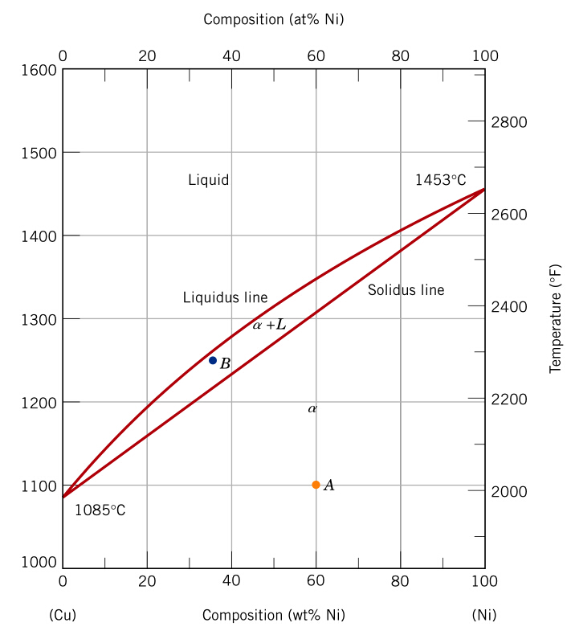

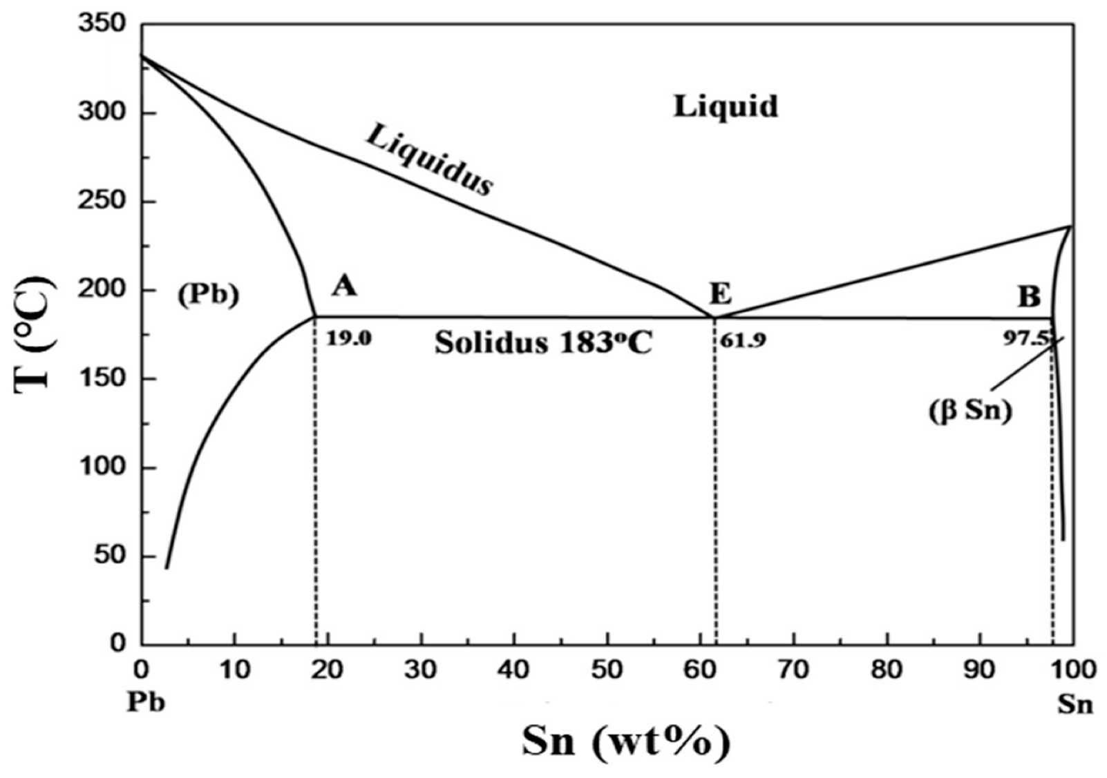

**LEVER RULE METHOD:** This method is used to find the mass fraction of different phases in a two-phase region.

**LEVER LINE:** It’s an isothermal line drawn in a two-phase region.

|  |  |
| --- | --- |
| $$m_{s}=\frac{C_{o}-C_{l}}{C_{s}-C_{l}}$$ $$m_{l}=1-m_{s}=\frac{C_{o}-C_{s}}{C_{s}-C_{l}}$$ | $$m_{l}+m_{s}=1$$ $$And C_{l}m_{l}+C_{s}m_{s}=C_{o}$$ $$C_{o}=concentration of Element 1 at which m_{l},m_{s} are calculated$$ $$C_{l}=concentration of Element 1 at which Complete Liquid State$$ $$C_{s}=concentration of Element 1 at which Complete Solid State$$ |

**TYPE-II: Pb-Sn ALLOY EUTECTIC PHASE DIAGRAM:**

|  |  |  |  |
| --- | --- | --- | --- |
| $α$**-Phase:**  Solvent = Pb,  Solute = Sn | $β$**-Phase:**  Solvent = Sn,  Solute = Pb | **Eutectic Reaction (Equilibrium): $$Liquid ⇋Solid 1+Solid 2$$**  E.g. $Liquid \underset{↔}{62\% Sn \& 183 °C}α+β$ | **At Eutectic Point:**  P = 3 (S, L),  C = 2 (Pb-Sn),  F + P = C + 1,  F = 0. |
| **Application:** | Soldering: (75% Sn + 25% Pb), Plumbing: (75% Pb + 25% Sn), Tinman: (50% Sn + 50% Pb) | | |

|  |  |  |
| --- | --- | --- |
| **Total $α$: $$m_{Total α}=\frac{C_{β}-C_{o}}{C_{β}-C_{α}}$$** | **Pro-Eutectic $α$: $$m_{Pro-Eutectic α}=\frac{C_{E}-C_{o}}{C_{E}-C_{α}}$$** | **Eutectic $α$: (E.g. $α$ phase present in Eutectic mixture) $$m_{Total α}=m_{Eutectic α}+m_{Pro-Eutectic α}$$** |

**TYPE-II: Fe-Fe3C ALLOY EUTECTIC PHASE DIAGRAM:**

|  |  |
| --- | --- |
| 1. It’s interstitial solid solution. 2. At room temperature, Fe structure is BCC. So Maximum interstitial Space, 3. Maximum solubility of carbon in Fe is only up to 6.67 wt% of carbon. If the %C is more than 6.67%, it will occupy on the surface of iron as graphite. 4. Cementite (**Fe3C**): It’s a hard phase material with complex **orthorhombic structure**. It’s formation increases with increasing in carbon percentage. 5. Based on %C, the Fe-C alloys are two types,    1. Steel: 0.008% to 2.1 %    2. Cast Iron: 2.1% to 6.67% 6. Allotropy: The iron material exhibits different crystal structures with different temperature. | Iron Carbon diagram |
| |  |  |  |  |  |  | | --- | --- | --- | --- | --- | --- | | At Room Temp | $α$-Fe | BCC | APF = 0.68 | Vuc is More | $ρ$ is Less | | Above 910 $°$ C | $γ$-Fe | FCC | APF = 0.74 | Vuc is Less | $ρ$ is More |   % of Volume Decrease = 8.14%   1. It’s good ferromagnetic material and in this material all magnetic dipoles are aligned in the direction of the field.   The ferromagnetic material depends on temperature and at curie temperature, it transforms into paramagnetic material. The Curie Temp. = 768 C   1. Melting point temperature decreases with increasing in C%. E.g. 2. No. of phases present in Fe-C Alloy = 5  |  |  |  |  | | --- | --- | --- | --- | | Sr. No. | Phase | Max. Solubility of C (%) | Structure | | 1 | $δ$-Fe | 0.09 | BCC | | 2 | $γ$-Fe (Austenite) | 2.1 | FCC | | 3 | $α$-Fe ($α$-ferrite) | 0.025 (Due to Tetrahedral sites) | BCC | | 4 | Fe3C (Cementite) | 6.67 (Due to Octahedral sites) | Orthorhombic | | 5 | Liquid |  |  | | |

1. Equilibrium Reaction: Draw Grain Structure for each reaction.

|  |  |  |  |
| --- | --- | --- | --- |
| 1 | Eutectic Reaction:  Eutectic Mixture $$Liquid ⇋Solid 1+Solid 2$$ | $Liquid \underset{↔}{4.2\% C, 1100 °C}γ-Fe+{Fe}_{3}C$ At Eutectic Point,  P = 3 (L, γ, Fe3C), C = 2 (Fe, C),  F + P = C + 1,  F = 0. | Types of Cast Iron Based on Eutectic point,  Hypoeutectic Steel: 2.1 to 4.2 % C  Hypereutectic Steel: 4.2 to 6.67 % C |
| 2 | Eutectoid Point:  Eutectoid Mixture Or Perlite $$Solid 1 ⇋Solid 2+Solid 3$$ | $$γ-Fe \underset{↔}{0.8\% C, 728 °C}α-Fe+{Fe}_{3}C$$ At Eutectoid Point,  P = 3 (L, γ, Fe3C), C = 2 (Fe, C),  F + P = C + 1,  F = 0. | Types of Steels Based on Eutectoid point,  Hypoeutectoid Steel: 0.008 to 0.8%C  Hypereutectoid Steel: 0.8 to 2.1% C |
| 3 | Peritectic Reaction: $$Liquid+Solid 1 ⇋Solid 2$$ | $$L+δ-Fe\underset{↔}{0.18\% C, 1450 °C}γ-Fe$$ At Peritectic Point,  P = 3 (L, γ, δ), C = 2 (Fe, C),  F + P = C + 1,  F = 0. |  |
| 4 | Monotectic Reaction:  (Non-Equilibrium Reaction) | $$Liquid ⇋Liquid1+Liquid2$$ $$L\underset{↔}{0.57\% C, 1450 °C}L+ γ-Fe$$ |  |
| 5 | Peritectoid Reaction:  Not present in the diagram. | $$Solid 1+Solid 2⇋ Solid 3$$ |  |

1. **TERTIARY PHASE DIAGRAM (C = 3)**

This Diagram is drawn for three component system and in this diagram 3 chemical compositional axis are considered in 2-D plane in an equilateral triangle form and temperature axis is considered perpendicular to the plane. And hence, it’s also known as 3-D Phase Diagram.

E.g. 18- 8 Stainless Steel (18% Cr, 8% Ni, 74% Fe)

At an equilibrium point, Degree of Freedom is Zero.

No. of Component C = 3 (Tertiary Diagram)

According to modified Gibbs Phase Rule,

F + P = C + 1,

Pmax = 4.

